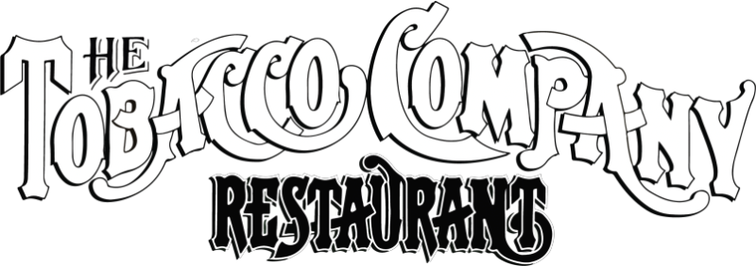

1201 East Cary Street | Richmond, VA | 23219

Thank you for considering The Tobacco Company Restaurant to host your event. Since 1977, our establishment has delighted guests in the historic Shockoe Slip with exceptional food, beverage, and service. What was once a tobacco warehouse, dating back to 1866, has become a nationally recognized dining and entertainment facility. Enhanced with furnishings from around the world, The Tobacco Company Restaurant stands as a unique and elegant fixture in Richmond’s history.

Available venues include the stunning, new Art Deco Lounge, the trendy Tobacco Company Club downstairs, and our secluded Shockoe Area on the third floor. From formal dinners to casual cocktail parties, our restaurant offers a refined, welcoming atmosphere suitable for any kind of event. For over 40 years, The Tobacco Company has been the setting of many special memories and has stood as the foundation of the Shockoe Slip. We take pride in our reputation and look forward to exceeding your expectations.

Please see the following pages for more information, such as rental fees, food and beverage minimums, maximum occupancies, and menus. Our special events team is available should you have any additional questions. Feel free to contact us via email at sales@dinetcr.com or at (804) 782-9555, extension 520.

Sincerely,

Sales & Events
The Tobacco Company Restaurant & Club
Venues
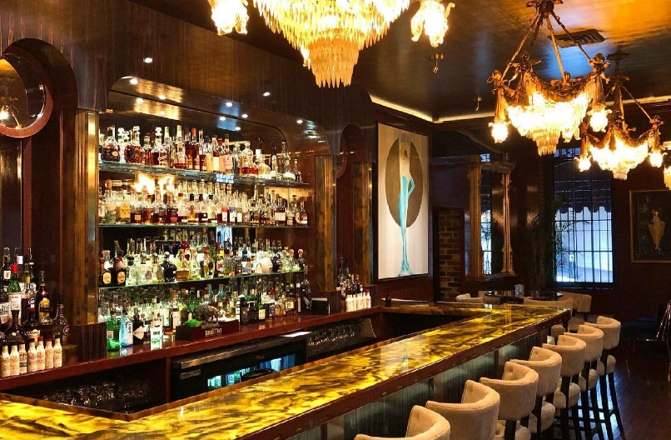
On our first floor is our semi-private lounge, The Art Deco Lounge; it features Art Deco and 1920s-inspired decor, high top tables, booths, and couches, and a full bar. The lounge accommodates up to 30 guests, seated, with a capacity of 40 people.

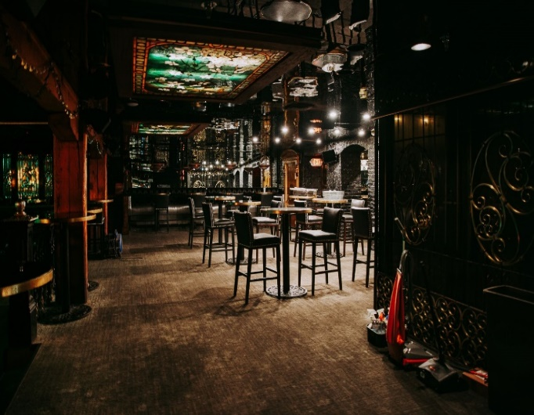
The Tobacco Company Club is a fully private venue with a separate entrance for you and your party. It features two full bars, a state-of-the-art sound system, and a dance floor. Here we can host full banquet events or more casual cocktail parties. Currently, the Club Room can seat up to 50 guests, with a maximum capacity of 200.
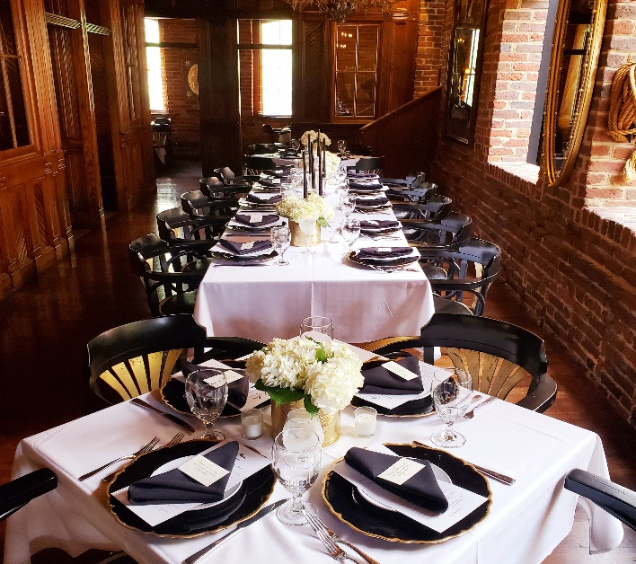

The Shockoe Table is the largest table set-up in the regular dining area. It is on the third floor, so it is only semi-private, as there are a few office tables nearby. This area can seat between 13 and 22 people, and guests will order from the regular dinner menu.

Room Fees / Food & Beverage Minimum Rates

The room rate is based on the area your group will be seated in. Other diners may be on the same floor as your group.

Cancelation fee:
A 25% cancelation fee will be applied for any cancelation within 14 days of your event.

The Tobacco Company Club*
Sundays - Wednesdays | $1000 rental fee, $1500 food & bar Minimum
Thursdays – Saturdays | $1500 rental fee, $2000 food & bar Minimum

The Art Deco Lounge
Sundays - Wednesdays | $500 rental fee, $850 food & bar minimum
Thursdays - Saturdays  The Shockoe Table | $800 rental fee, $1500 food & bar minimum
Monday – Sunday | $450 rental fee, $75 per person food & bar min.

Food and beverage minimums do not include applicable taxes, service charges, gratuity, or other incidental charges.

*Limited hours available, the club opens to the public from 8 PM to 2 AM Thursdays through Saturdays.

Special Event Guidelines

The Tobacco Company Restaurant and Club has established the following guidelines for special events:

You and your guests will have a dedicated wait staff for your event; thus, a contract must be received to guarantee your reservation.

All food selections must be finalized 3 weeks before your event date.

The Tobacco Company Restaurant is a working restaurant and not a catering venue; because of this, we cannot accommodate the following in the restaurant: wedding ceremonies, live music/DJs, and dancing, audio/video setups.

There is a minimum dollar amount required to guarantee your reservation, those are listed above. You will be charged for the minimum food/beverage expenditure or the actual attendance, whichever is greater.

This amount refers to food and beverage charges and does not decrease if the expected attendance is not reached; if the food and beverage minimum is not reached, the remainder of the minimum will be charged as a facility fee. Gratuities and sales tax do not contribute to the minimum expenditure and will be added to your final bill.

Billing will be one check for the entire party and will include a 12.8% tax and a 20% gratuity; all alcohol is billed on a per-consumption basis and will be reflected on the final bill. Payment will be received after the event unless otherwise prearranged.

For all functions, The Tobacco Company Restaurant must have a minimum guest count 14 days in advance and a final guest count 48 hours in advance. We cannot guarantee that we can accommodate any significant reductions or increases to the party size without prior confirmation.

If a contracted event is cancelled within 14 days of the event a cancellation fee of 25% of the room rental, food and beverage minimum will be charged. Cancellations made within three days of the event will result in a cancellation fee of the full food and beverage minimum.

In the months of November through January, if an event is canceled within thirty days of the event, the cancellation fee will equal the food and beverage minimum or $60 per person for the number originally contracted for, whichever is greater.

Menu Options

Catering Hors D’oeuvres Menu

Prices are per 50 count

Vegetable Spring Roll $110

Cabbage, carrot, celery, and onion inside a wheat flour wrapper.

Lemongrass Chicken Dumplings $120

A refreshing mix of chicken, lemongrass, corn, scallion, onion

Shrimp market price, sold by the pound

(15-20 count a pound)

Asparagus with Asiago Cheese $135

Philly wrapped dough, with shredded Asiago cheese

Chicken Drumettes $150
With your choice of plain, barbeque, or buffalo sauce

Spanakopita $110

Chopped spinach, chopped onions, and feta cheese wrapped in flaky filo dough

Crab Cakes $200

Jumbo lump crab and chives served with Cajun Tartar Sauce

Fruit Platter Small $72, Large $145

Fresh seasonal fruits with strawberry

Crudité $125

Fresh vegetables

Traditional Hummus $100

Cucumber and carrot chips, grilled pita

Chicken Salad $130

Chicken breast, mayo, house seasoning, Arugula, Roma tomatoes, mini croissants

Cheese Platter Small $92, Large $185

Assortment of imported and domestic cheese, crackers,

Spinach & Artichoke Dip $130

Spinach and artichokes mixed with cream cheese, served with pita chips

Coconut Shrimp $175

Thai chili mango sauce, Cajun tartar sauce

Meatballs $160

Made from our famous meatloaf recipe, baked in tomato sauce with Parmesan and fresh basil.

Caesar Salad $150

Romaine lettuce, Parmesan-Reggiano, croutons, House-made Caesar dressing

Desserts: French Macaroons $150, Mini Cheesecake Bites $110

**The following options must be discussed with the event/sales team. They are not necessarily available for every space or event. Listed prices are subject to change, due to market price.

Pasta Stations**
Priced per Person

Tortellini Pasta $8.00
Tossed with Chunky Tomato Marinara Sauce & Pesto.
or
Penne Pasta $8.00
Tossed with Vegetables and Alfredo Sauce.

Add Chicken $1.00 Per Person, Add Shrimp $5.00 Per Person

Carving Stations**
Top Sirloin, Turkey, and Ham carving stations are available upon request in the Tobacco Company Club only. Please contact our sales team regarding pricing and availability.

Beverage Options Menu

Open Bar
A. Unlimited – All guests may order whatever they want from the bar for the entire event. Total sales will be charged to the host.
*Choice of Unlimited (whatever guests would like)
*Choice of House Liquors (all drinks made for guests made with house liquor)
*Choice of Premium Liquors (all drinks made for guests made with premium liquor)

B. Capped – All guests may order whatever they want from the bar until they reach a capped or set amount of sales chosen by the host. For example, you may choose to offer a Capped Open Bar in which all guests may order whatever they like from the bar until the sales total to $1000.00. Once sales reach $1000.00 the bar tab will be closed.
*Choice of Unlimited (whatever guests would like)
*Choice of House Liquors (all drinks made for guests made with house liquor)
*Choice of Premium Liquors (all drinks made for guests made with premium liquor)

C. Separate Checks Bar – Guests order and pay for their own drinks in separate checks, and it is not included in your personal event bill.

Beer and Wine
A. Unlimited – All guests may order whatever they like from the Beer and Wine menu for the entire event. Total sales will be charged to the host.

B. Limited – Host may choose a set amount of beer or wine available for purchase for the guests.
*Pick price cap
*Pick beer or wine selection

Additional Information
DJ Services $400
Sound tech services include either operating of equipment for picture slideshow and prerecorded music OR full live DJ playlist complete with music videos and light show.
This service is only available in our Club.

Wine, Beer, & Cocktail List
We strive to keep our wine, draft beer, and liquor list as updated as possible. Due to the continually changing nature of our wine list, it is only available by request.
A corkage fee of $25 applies to any outside bottle of wine.

Deliveries
Floral arrangements, wedding/specialty cakes, and/or decorations may be delivered to The Tobacco Company Restaurant on the day of the event, during regular hours with prior management approval and must be removed at the close of the event. We will not be responsible for lost or stolen items brought in by guest or vendors hired by the guest. Please note that decorations are not allowed in the Art Deco Lounge other than small table pieces.

Parking
The parking deck located at 110 S 13th St Garage/ 12th and Canal St is managed by Lanier Parking solutions and is a flat $6 in the evenings.
The City of Richmond has provided space for up to 2 tour buses at 12th and Canal streets across from the Omni Hotel.
There are also various other parking lots located on Cary Street, along with street parking.

